An Intelligent Sales Forecasting System Using XGBoost and Time-Series Feature Engineering

Nilesh P. Sable
Computer Science & Engineering (AI) Vishwakarma Institute of Technology Pune, India
drsablenilesh@gmail.com

Abhishek Dhone Computer Science & Engineering (AI) Vishwakarma Institute of Technology
Pune, India abhishek.dhone24@vit.edu
Anita B. Dombale Computer Science & Engineering (AI) Vishwakarma Institute of Technology
Pune, India anita.dombale@vit.edu

Nikhil Dukare
Computer Science & Engineering (AI) Vishwakarma Institute of Technology Pune, India
nikhil.dukare24@vit.edu

Devesh Pathak
Computer Science & Engineering (AI) Vishwakarma Institute of Technology Pune, India
devesh.pathak24@vit.edu

Piyush Goswami Computer Science & Engineering (AI) Vishwakarma Institute of Technology
Pune, India piyush.goswami24@vit.edu

Abstract—The proposed project entails the development of an AI-based dashboard that predicts future sales based on past sales data inputted by the user. This work uses an XGBoost-based ensemble regression algorithm along with time-series feature engineering, such as lag features (lag-1, lag-7), rolling mean features (3 days, 7 days), calendar features, and a linear trend index. Backend programming utilizes FastAPI to allow model training per product category, temporal aggregations of sales per day, week, and month, and forecasting with confidence interval calculations for multi-step autoregressive models. The natural language query component utilizes the Google Gemini API and a rule-based method as a fall-back system to enable the user to interact with the database using conversational queries. Frontend coding employs React 19 and Recharts to render sales data in real-time. Model evaluation includes the metrics of MAE and a normalized accuracy, along with growth rate and volatility measures.
Index Terms—XGBoost, Sales Forecasting, Time-Series Prediction, Google Gemini API, FastAPI, React, Ensemble Learning, Natural Language Interface

- Introduction
Accurate sales forecasting is an important aspect of modern-day corporate strategy that allows businesses to manage their inventory, maximize resource utilization, and make proactive responses to changes in the market. In view of the huge amounts of data generated in the current retailing and e-commerce space, traditional methods of sales forecasting, including those based on moving average calculations and using spreadsheets, are no longer applicable. For this reason, machine learning-based forecasting models have become quite popular.
Even with the existence of modern methods of forecasting, there is still an evident gap between complex machine learning algorithms and usability for ordinary non-tech savvy people working within the framework of the corporate world. Most of the systems being used today either need high levels of coding skills from the users or are very costly, thereby restricting their use by small firms.
This paper presents the design and implementation of an AI-powered sales forecasting dashboard that addresses these challenges. The proposed system allows users to upload historical sales data in CSV format and instantly receive machine learning-driven forecasts, visual analytics, and conversational business insights — all through a web-based interface requiring no technical knowledge. The core forecasting engine is built upon XGBoost, a gradient boosted ensemble regression algorithm, enhanced with time-series feature engineering including lag variables, rolling means, and calendar-based features. A natural language query interface, integrated via the Google Gemini API, further enables users to interrogate their data using plain English.
Key contributions of this paper include:
- Development of an adaptive per-item XGBoost forecasting pipeline capable of learning and predicting from user-submitted datasets.
- Feature engineering pipeline for the time-series dataset using lagging variables, rolling means, and trend indexing for better predictive performance.
- Incorporation of the Google Gemini API to facilitate natural language interaction over the submitted sales dataset.
- Construction of the end-to-end web application using FastAPI and React 19, capable of aggregating data at different levels (daily, weekly, and monthly) with real-time charting capabilities.

- Literature Review

[1] Chen and Guestrin have developed XGBoost, a scalable and efficient method for building a gradient boosted decision tree that can deal with sparse datasets. The technique employs a unique algorithm for finding splits based on sparsity along with an innovative caching strategy that helps in achieving better results than other boosting approaches in terms of efficiency. The suggested model uses XGBoost as the forecasting engine since it is composed of an ensemble tree.

[2] The LSTM (Long Short-Term Memory) architecture was put forth by Hochreiter and Schmidhuber as a means of overcoming the vanishing gradient issue that is common to Recurrent Neural Networks. The use of gating systems, including input, forget, and output gates, allows for the selective retention and forgetting of data over long periods of time, thus modeling long-term dependencies. Although the model developed here makes use of the XGBoost algorithm instead of LSTM networks for prediction, the latter serve as a benchmark within time-series prediction research when evaluating ensembles.
[3] Prophet is a publicly available forecasting process created at Facebook and intended exclusively for time series with business data characterized by significant seasonality and holidays. Prophet breaks down a time series into three basic components, namely trend, seasonality, and holidays, making it possible for analysts to use their expertise when creating a forecasting model. Prophet can be regarded as one of the important algorithms used in sales forecasting studies and serves as the basis for future system implementation.
[4]Box, Jenkins, Reinsel, and Ljung were instrumental in laying down the groundwork for time-series analysis using the ARIMA class of models, developing a structured approach to model identification and estimation using autocorrelation analysis. Both ARIMA models and their seasonal counterpart SARIMA have found wide application as benchmarks in forecasting due to their ability to deliver superior results while being easily understandable. The lagging and moving average feature extraction process used in our system is fundamentally derived from this autoregression model paradigm.
[5] Pedregosa et al. introduced the Scikit-learn, an efficient and effective open-source machine learning library for Python implementing supervised and unsupervised learning algorithms, pre-processing, and model evaluation functionalities. Due to its robust architecture and documentation, it is considered the industry standard for Python-based machine learning applications. Scikit-learn is used in our proposed framework to split the data set into training and testing partitions and calculate mean absolute error.
[6] Pandas was developed by McKinney and is an open source, data manipulation library for Python which offers DataFrame objects as well as many functions to manipulate data including data cleansing, transformations, aggregations, and resampling. Being inherently built around datetime indexing and resampling based on periods, Pandas is especially useful in working with time series data.
[7] Makridakis et al. carried out an extensive comparison analysis between conventional statistical techniques and state-of-the-art machine learning approaches for a wide variety of time series data. According to their results, conventional approaches often proved superior to sophisticated machine learning algorithms when handling short univariate time series data. The above study emphasizes the necessity of using time-series feature engineering in the proposed model, where lagged, moving average, and calendar features are added to the XGBoost model.
[8] Akiba et al. introduced the Optuna framework that uses a Tree-structured Parzen Estimator sampler for optimizing hyperparameters, achieving superior efficiency and effectiveness compared to the grid search and random search algorithms. Although the suggested approach applies fixed hyperparameters for XGBoost, the utilization of Optuna is considered a viable path for future research to enhance the precision of the prediction model.
[9] Géron has offered an extensive practical manual on machine learning and deep learning that includes the best practices related to supervised learning algorithms, feature engineering, model assessment, and hyperparameter optimization. The proposed system's data preprocessing approach and its training-validation set division method are consistent with the best practices described in this source. For instance, the training-validation split based on the chronological order is used in the proposed system in order to avoid any possible data leakage problem.
[10] Tyagi performed research into the use of different machine learning methods, such as linear regression, decision trees, and support vector machines, for predicting sales based on historical retail data. The results of the work clearly showed that ensemble models were always superior to individual models in terms of prediction performance in cases where sales time series displayed non-linear trends. These results can be used to prove the choice of XGBoost as the main model for forecasting within the suggested system.

- Methodology
This chapter details the technological process used for the creation of the forecast system in question, including data preprocessing methods, feature generation, model training, prediction processes, and evaluation metrics.

- Data Preprocessing
The system allows users to upload CSV files with at least two columns: Date and Sales. After uploading, the input data is preprocessed as follows:
- Dates are parsed according to mixed format with the day-first assumption, and those rows that cannot be parsed are discarded.
- Sales are converted into numeric type, and those rows that have missing or non-numeric sales values are deleted.
- When there is a Products column, the data is split according to products, and then each part is preprocessed separately.

- Feature Engineering
For the XGBoost algorithm to learn both time-based and sales-related trends, eight features are created from the cleaned dataset. Table I shows the entire set of features created.
Feature | Formula | Purpose
Day | $$d=\text{date.day}$$ | Intra-month pattern
Month | $$m=\text{date.month}$$ | Seasonal pattern
Day of Week | $$dow=\text{date.dayofweek}$$ | Weekly pattern
Trend | $$trend=0,1,2,…,n$$ | Long-term progression
Lag-1 | $$lag_{1}=y_{t-1}$$ | Short-term dependency
Lag-7 | $$lag_{7}=y_{t-7}$$ | Weekly dependency
Rolling Mean (3-day) | $$RM_{3}=\frac{1}{3}\sum_{i=0}^{2}{y_{t-i}}$$ | Short-term smoothing
Rolling Mean (7-day) | $$RM_{7}=\frac{1}{7}\sum_{i=0}^{6}{y_{t-i}}$$ | Weekly smoothing
Table I: Engineered Feature Set

- Model Training
The base forecasting model is called XGBoost (Extreme Gradient Boosting). This is an ensemble learning technique based on the principle of building an additive tree model via boosting. The formula of the prediction is:
$$\hat{y}=\sum_{k=1}^{K}{f_{k}\left(x\right), f_{k }∈ F}$$

where $K$is the total number of trees, $f_{k}$represents the $k$-th decision tree, $x$is the input feature vector, and $F$is the space of regression trees.

Hyperparameter setting for the model includes 300 estimators, a learning rate of 0.05, max tree depth of 7, subsampling of 0.8, and subsampling columns ratio of 0.8. Splitting data temporally, train set takes up 90 percent while the rest serves as testing set. Shuffling is not enabled to retain time order.

- Autoregressive Future Prediction
Future sales forecasting is performed through an iterative autoregressive mechanism. For each future time step $t$, the model predicts ${\hat{y}}_{t}$ using features derived from previously predicted values. The prediction loop operates as follows:
- Compute calendar features (day, month, day of week) for the next date.
- Update the trend index: $trend_{new}=trend_{last}+1$
- Compute lag features from the most recent actual or predicted values:
$${lag}_{1}= {\hat{y}}_{t-1}, { lag}_{7}= {\hat{y}}_{t-7},$$
- Compute rooling means :
$${RM}_{3}=\frac{{\hat{y}}_{t-1}+ {\hat{y}}_{t-2}+{\hat{y}}_{t-3}}{3}$$

- Generate prediction ${\hat{y}}_{t}$ and append the sequence for sub sequent iteration.
Approximate confidence intervals are computed as:
$lower=0.9 . {\hat{y}}_{t}$ , $upper=0.9 . {\hat{y}}_{t}$

- Performance Evaluation Metrics
Model performance is evaluated using the following metrics:

Mean Absolute Error (MAE):
$MAE=\frac{1}{n}\sum_{i=0}^{n}{∣y_{i}- {\hat{y}}_{i}∣}$
Custom Normalized Accuracy:
$Accuracy=max⁡(0, 100- \frac{MAE}{\max\left(y\right)-(min⁡(y)} × 100)$
Sales Growth Rate :
$Grouth= \frac{{\overline{y}}_{last }- {\overline{y}}_{first} }{{\overline{y}}_{first}} ×100$
where ${\overset{‾}{y}}_{first}$and ${\overset{‾}{y}}_{last}$are the mean of the first and last 10 sales values respectively.
Volatility (Standard Deviation):
$$σ= \sqrt{\frac{1}{n} \sum_{i=1}^{n}{{(y_{i}- \overset{̿}{y})}^{2}}}$$

- System Architecture
The proposed system shall be developed as a full stack web application based on a three tier architectural model comprising a frontend written in React, a backend powered by FastAPI, and an API of the Google Gemini platform for NLP queries processing. Each component takes care of its particular role within the system.
- Frontend Dashboard Interface
React 19 is used in the frontend implementation, where Vite is used for building purposes, while Tailwind CSS is used for responsive design. Three main pages comprise the application, namely, the HomePage, LoginPage for user authentication, and Dashboard page, which is the main feature of the app. In the Dashboard, the users can upload CSV files, define periods for the aggregations, forecast sales, and view them. For displaying the sales data, the Recharts library is used with a LineChart element, which shows both historic and forecasted sales with their confidence intervals. All the communications with the backend are made via the Axios client.
- Backend API Server
The backend system has been developed using FastAPI and consists of four RESTful endpoints that handle all the important tasks in the system. The /upload endpoint supports the loading of CSV files and kickstarts the data analysis and model training process. The /predict endpoint provides predictions regarding the sales forecast for a certain number of days provided by the user. The /aggregate endpoint provides period-based summaries of sales for daily, weekly, or monthly intervals. The /chat endpoint receives natural language questions from the users and sends responses back by using the Google Gemini API.
- Data Ingestion and Preprocessing Module
After uploading a CSV file to the system, checks for the presence of certain essential columns are done, and then the file goes through an automated process of data preparation involving various operations. Date and sales columns are processed with their incorrect values eliminated; the sales figures undergo conversion into numerical values with any blanks or nulls eliminated. Finally, the data set is sorted based on chronological order and resampled using Pandas in accordance with the time interval chosen by the user..

- Machine Learning and Forecasting Module
The backbone of the forecast model relies on the gradient boosting regressor model of XGBoost. After the preprocessing phase, eight features are generated from the processed dataset for the purpose of predicting the future sales. The model is trained on a temporal 90-10 train-test split and is cached in the server memory for future predictions. The future sales forecasting task is done via the use of an iterative autoregression process where each prediction result becomes the input feature for the next time step. Each item can be independently predicted by training and maintaining an individual model for each product found in the data..
- Natural Language Query Module
The conversation querying process utilizes the Google Gemini API. When the user enters a natural language question in the conversation interface, the back end generates an instant statistical analysis of the current data set that includes information on total sales, average sales, maximum/minimum values, and individual product sales, and then adds this information as context to a prompt sent to the API. The system includes a local fallback for keyword-based questions such as total sales, average sales, and product analysis if the API does not respond..

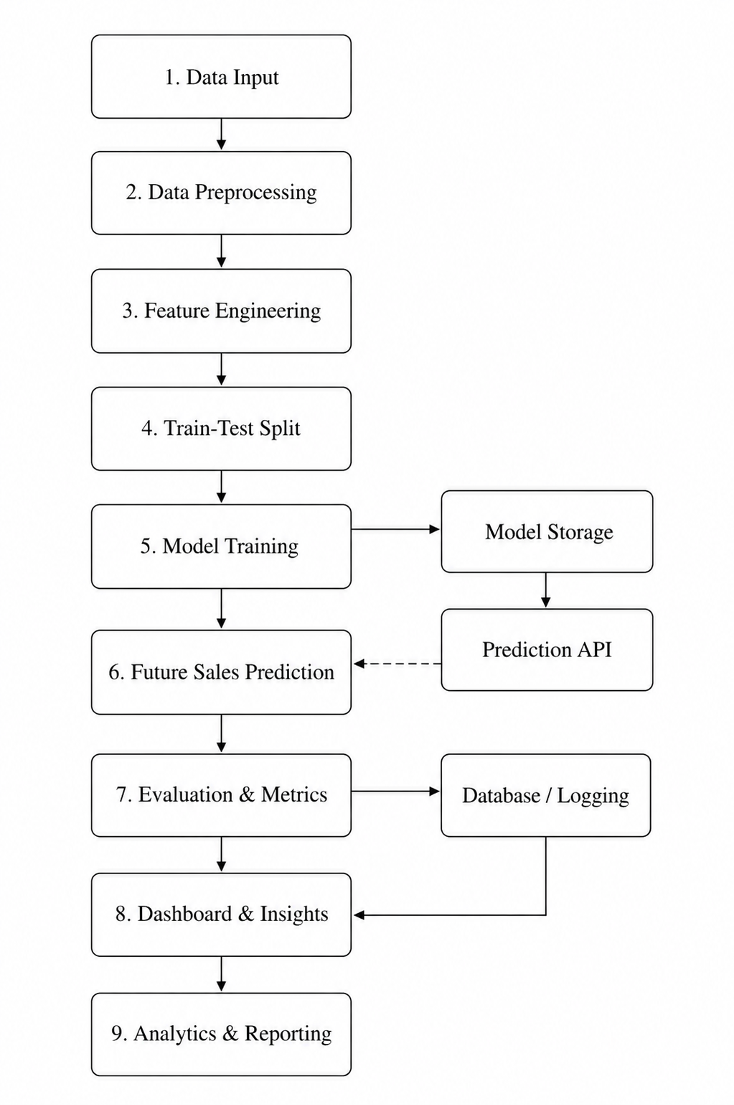
Fig. 1. Overall system architecture of the proposed AI-powered sales forecasting dashboard.

- Results
The following section will provide the experiment results of the proposed sales prediction framework by testing its performance on the advanced_sales_dataset.csv data set that includes multivariate sales data for 83 days and eight different products.

- Dataset Description
The data for evaluation consists of sales data on a daily basis of eight categories of consumer products that include Bread, Chips, Chocolate, Cold Drink, Milk, Oil, Rice, and Soap. There are a total of 83 days of information available, and there is an attribute that includes the product type, prompting the system to train separate models for each product independently using XGBoost algorithms.

- Model Performance
Evaluation of the XGBoost classifiers was performed by measuring the Mean Absolute Error (MAE) as well as the proposed normalized accuracy measure discussed in section III. The total prediction accuracy of the system was found to be 94.29%. Table IV shows a summary of model evaluation metrics used in this study..
Metric | Value
Forecasting Accuracy | 94.29%
Growth Rate | 32.97%
Volatility (σ) | 36.06
Dataset Duration | 83 Days
Number of Products | 8
Models Trained | 8 (per product)
Table IV: Model Performance Metrics
Growth rate, at 32.97%, shows that there is a strong positive trend in terms of sales during the whole dataset period, obtained by calculating the percentage difference between the average of the first and last ten values for sales. The volatility at 36.06 shows that there is moderate variability in sales on a daily basis.

- Per-Product Sales Analysis
The system worked successfully to come up with sales figures and predictions for all eight products individually. Table V shows the total sales per product during the 83 days of analysis.

Product | Total Sales (USD)
Bread | 18,166.28
Milk | 14,873.63
Chips | 13,361.04
Soap | 11,426.57
Oil | 10,967.06
Chocolate | 10,621.36
Rice | 10,249.75
Cold Drink | 7,430.59
Total | 97,096.28
Table V: Per-Product Total Sales (83-Day Period)

The category with the highest total sales was Bread at $18,166.28, whereas Cold Drink had the lowest sales of $7,430.59. The total sales from all categories over the 83 days were $97,096.28.

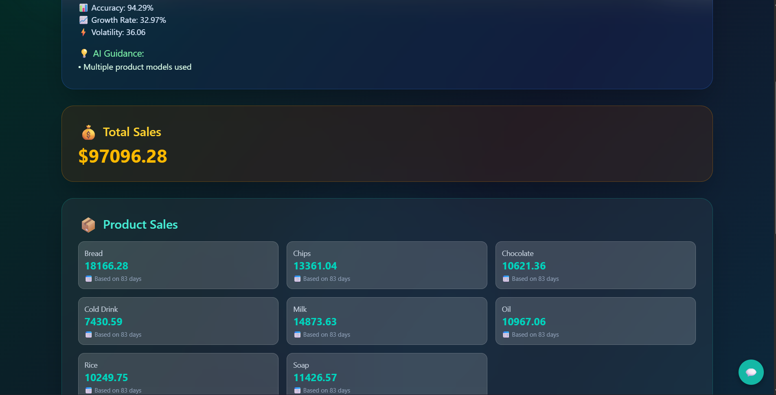

Fig. 2. Sales dashboard illustrating total revenue, product-wise distribution, and key performance metrics

- Forecasting Output

Future sales predictions were effectively computed by the autoregressive multi-step forecast algorithm for a given number of days following the most recent date entered by the user. Each predicted value was provided with an estimated range based on 10% error (+/-) in predicting the value. Real-time visual presentation of forecasted sales values was done using a Line Chart overlayed on the Dashboard.

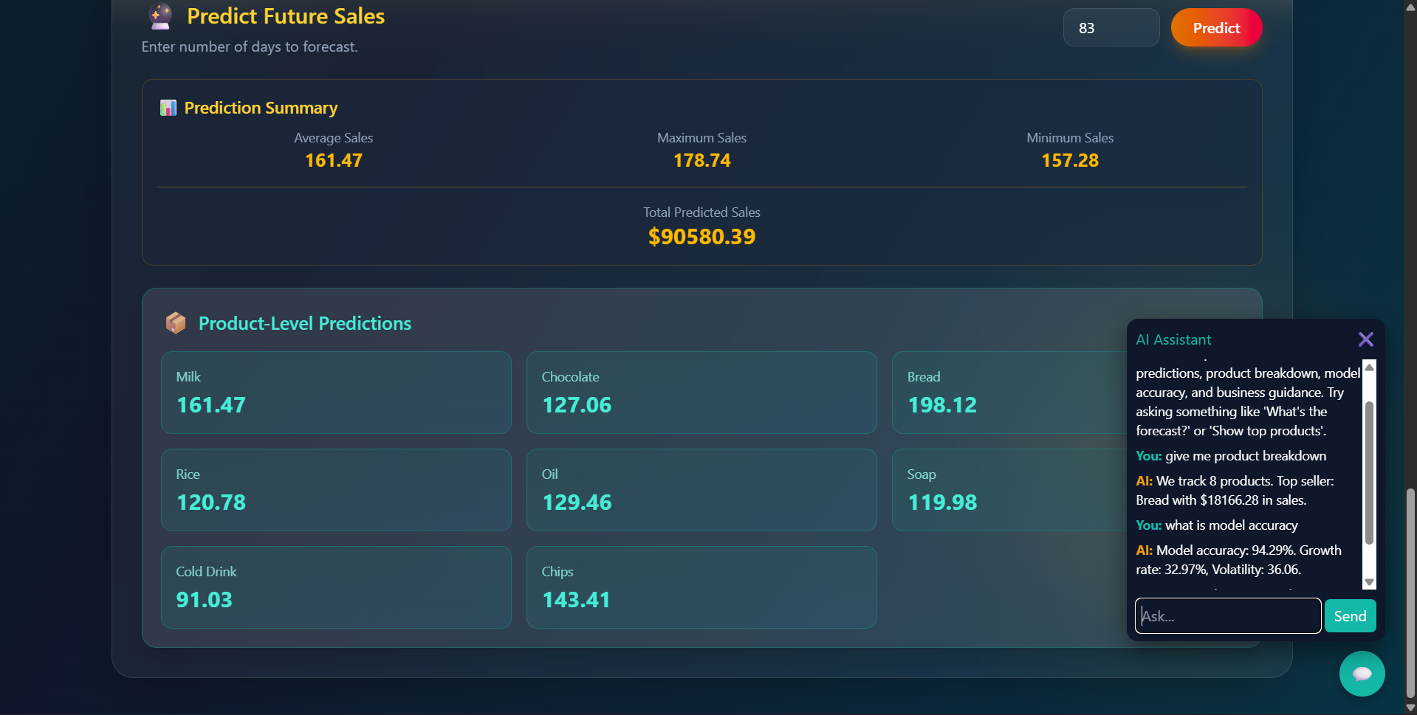

Fig. 3. Prediction dashboard displaying forecasted sales summary, product-level predictions, and AI-assisted insights for decision support.

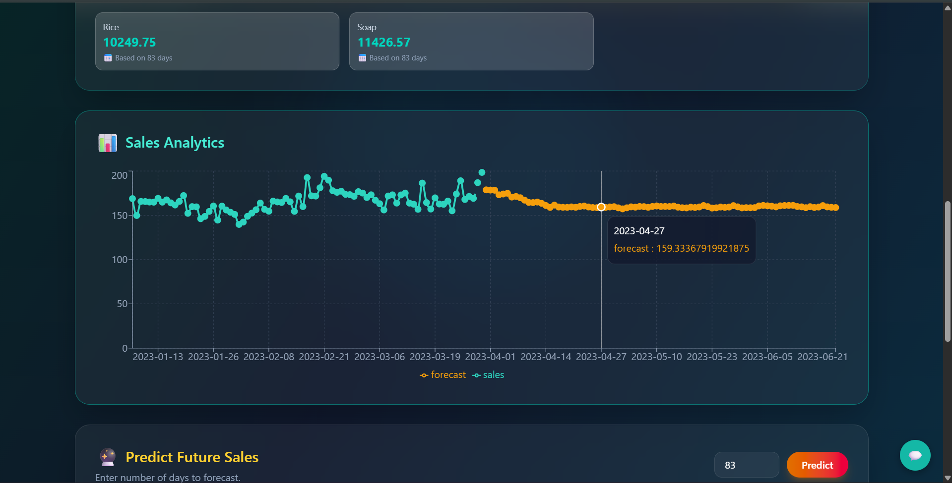

Fig. 4. Time-series visualization comparing historical sales with forecasted values generated by the predictive model.

- Conclusion
In this study, the development, implementation, and evaluation of an artificial intelligence based dashboard for sales forecasting is described, which allows non-technologists to use the power of machine learning to predict their sales using a user-friendly web-based interface. The suggested solution is based on a time-series analysis, wherein XGBoost ensemble regression algorithm is coupled with a feature engineering pipeline consisting of lagged variables, moving averages, calendar-based features, and a linear trend index. Results obtained from real-life sales data consisting of eight different product categories collected during 83 days reveal forecasting accuracy of 94.29%, 32.97% increase in sales, and 36.06 volatility.
Going forward, efforts will be made to incorporate persistent storage through MongoDB Atlas, enhance the forecasting engine with new algorithms like ARIMA and Facebook Prophet in order to make comparisons between the various models, use statistics-based prediction intervals in lieu of approximation, and deploy the entire system in a cloud environment for multi-user interaction capability.

- Future Scope
The present architecture stores trained models in the server’s memory, thus confining its use to only one user at a time and erasing model parameters whenever there is a rebooting of the server. To overcome this limitation, the next phase of development would include implementing the use of MongoDB Atlas for storing models permanently, thus facilitating multiple users’ simultaneous use. Moreover, the prediction engine will also be upgraded to utilize additional models like ARIMA, SARIMA, and Facebook Prophet, which can be compared for better performance and model selection depending on data properties..
Future improvements will center around leveraging the system through a cloud infrastructure like AWS or Google Cloud by utilizing containerization techniques via Docker for scalability and availability. The natural language query functionality will be improved to enable the multi-turn conversation context where subsequent questions can be asked and business suggestions can be made proactively. Other external variables, including holiday schedules, promotions, and economic data, will be considered for inclusion in the feature engineering process as well.

Acknowledgment
The authors would like to extend their heartfelt appreciation to the teaching and non-teaching staff of the Department of Computer Science and Engineering for their unrelenting assistance and advice throughout this study. In addition, special appreciation is due to the project guide for their insightful comments and suggestions during the design and testing phase of this study. Finally, the authors would like to thank the open-source communities that developed the FastAPI, XGBoost, React, and Recharts frameworks that enabled this study..

References

[1] T. Chen and C. Guestrin, "XGBoost: A scalable tree boosting system," in Proc. 22nd ACM SIGKDD Int. Conf. Knowledge Discovery and Data Mining, San Francisco, CA, USA, 2016, pp. 785–794.
[2] S. Hochreiter and J. Schmidhuber, "Long short-term memory," Neural Computation, vol. 9, no. 8, pp. 1735–1780, Nov. 1997.
[3] S. J. Taylor and B. Letham, "Forecasting at scale," The American Statistician, vol. 72, no. 1, pp. 37–45, Jan. 2018.
[4] G. E. P. Box, G. M. Jenkins, G. C. Reinsel, and G. M. Ljung, Time Series Analysis: Forecasting and Control, 5th ed. Hoboken, NJ, USA: Wiley, 2015.
[5] F. Pedregosa et al., "Scikit-learn: Machine learning in Python," Journal of Machine Learning Research, vol. 12, pp. 2825–2830, Oct. 2011.
[6] W. McKinney, "Data structures for statistical computing in Python," in Proc. 9th Python in Science Conf., Austin, TX, USA, 2010, pp. 56–61.
[7] S. Makridakis, E. Spiliotis, and V. Assimakopoulos, "Statistical and machine learning forecasting methods: Concerns and ways forward," PLOS ONE, vol. 13, no. 3, pp. 1–26, Mar. 2018.
[8] T. Akiba, S. Sano, T. Yanase, T. Ohta, and M. Koyama, "Optuna: A next-generation hyperparameter optimization framework," in Proc. 25th ACM SIGKDD Int. Conf. Knowledge Discovery and Data Mining, Anchorage, AK, USA, 2019, pp. 2623–2631.
[9] A. Géron, Hands-On Machine Learning with Scikit-Learn, Keras, and TensorFlow, 3rd ed. Sebastopol, CA, USA: O'Reilly Media, 2022.
[10] S. Tyagi, "Sales forecasting using machine learning algorithms," Int. Journal of Computer Applications, vol. 175, no. 2, pp. 12–18, Feb. 2020.

